Jalen Powell

January 20, 2023

COMP 4200

Homework 1

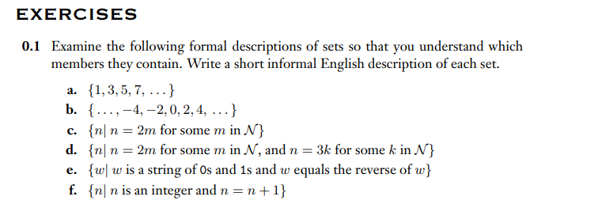

F.) This set is an empty set. E.g., n=3 => 3 != 3+1

E.) This set holds the string *w* of 0s and 1s while having the reverse values of *w*.

D.)

The range of function g is {6,7,8,9,10}

The domain of function g will contain the values of X and Y.

X ~ {1,2,3,4,5}

Y ~ {6,7,8,9,10}

Domain is equal to X * Y =

{(1, 6) (1, 7) (1, 8) (1, 9) (1, 10) (2, 6) (2, 7) (2, 8) (2, 9) (2, 10) (3, 6) (3, 7) (3, 8) (3, 9) (3, 10) (4, 6) (4, 7) (4, 8) (4, 9) (4,10) (5, 6 ) (5, 7) (5, 8) (5, 9) (5, 10)}

E.) The value of g(4, f(4)) is g(4, 7) which is the number **8**.

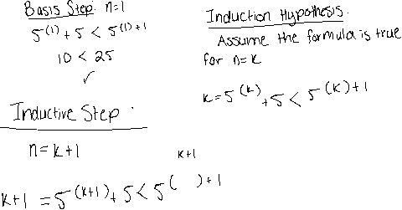

* The formula remains true with *n* being either 1,2, or k+1. The induction hypothesis was correct.



* The formula remains true with *n* being either 1,2, or k+1. The induction hypothesis was correct.